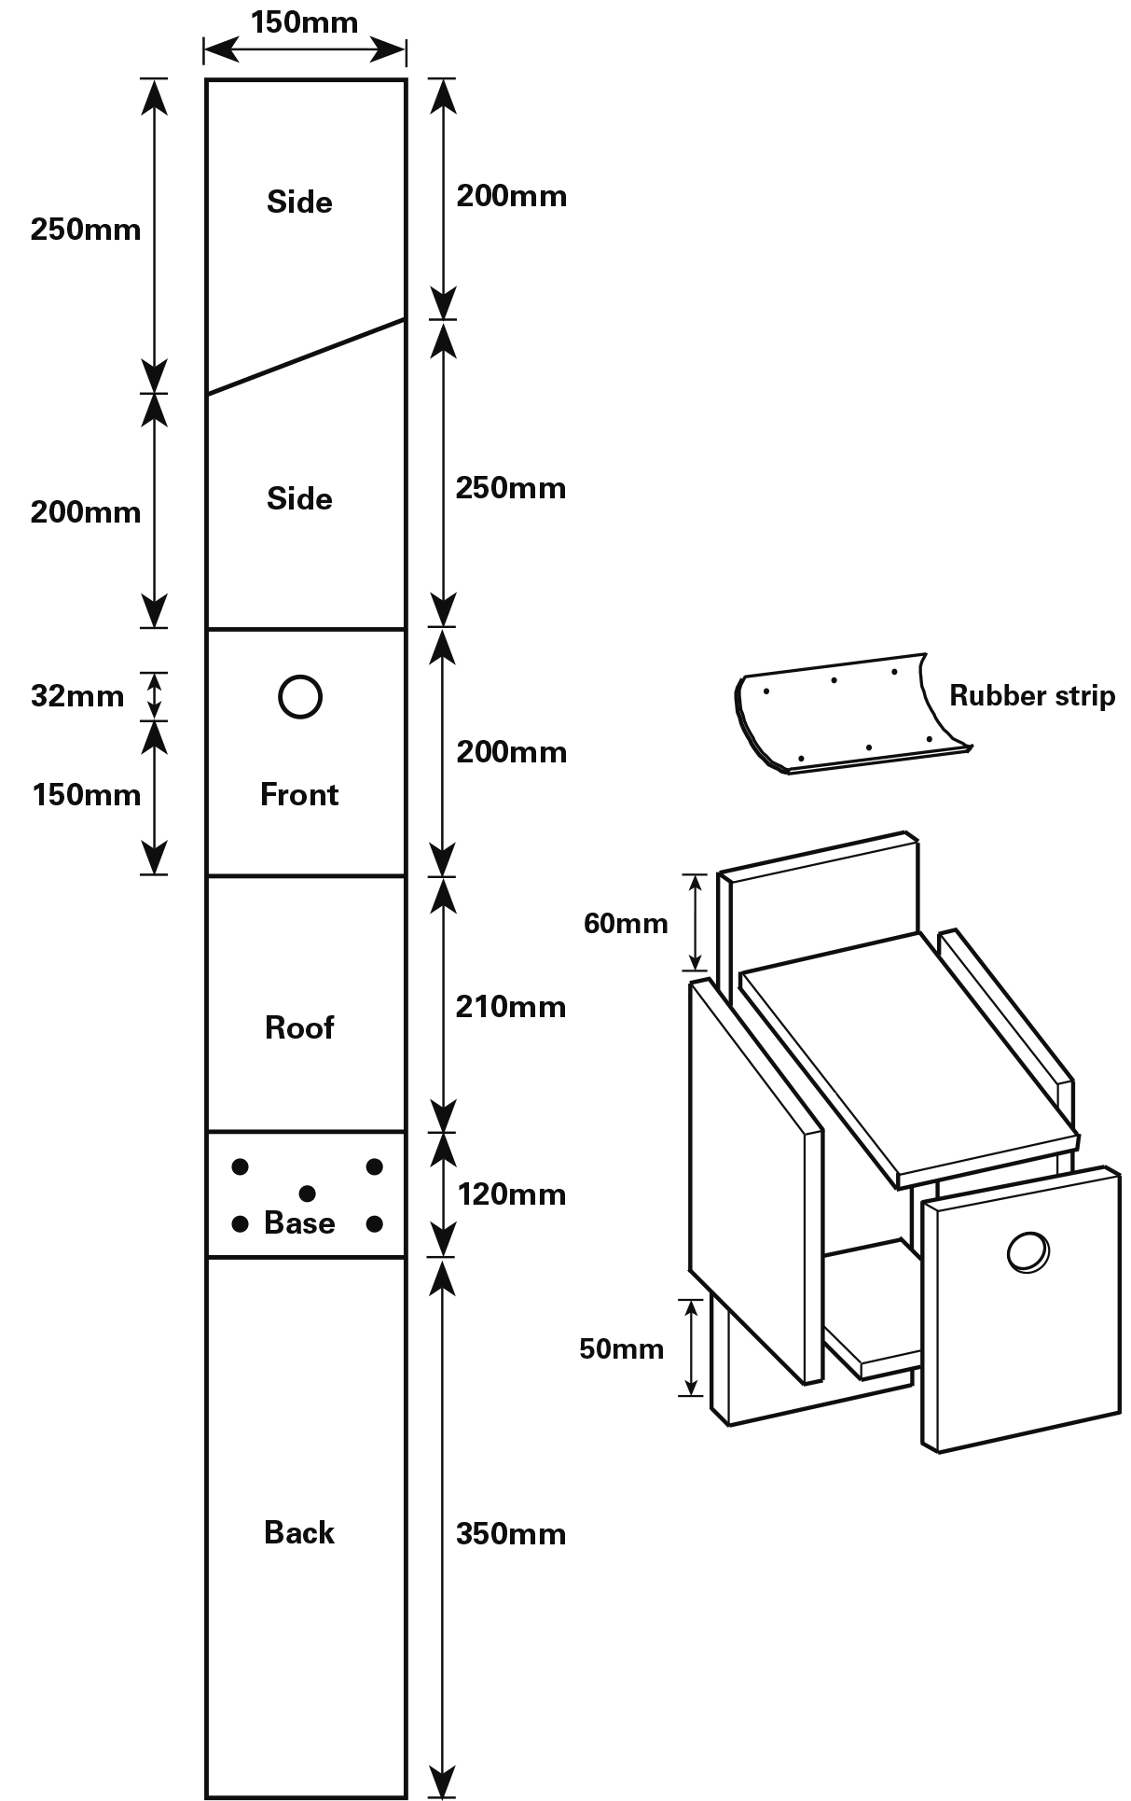
- Find the right bird-friendly spot for your box. Ideally, it will be under the eaves of your house or high on a wall, well away from curious cats or foxes! Make sure you get permission if you need it.
The box will need to be at least 3 metres (10 feet) from the ground, facing somewhere between north and east to avoid it getting too hot or wet. Avoid placing it in direct sunlight and don't put it over a doorway or well-used path.
- Make sure you have the right wood. The thickness is important to insulate the box from cold and heat and to stop the box warping. You can use exterior-quality plywood (for a light box) or, for something more sturdy, hardwoods (such as oak and beech) or soft wood (such as pine, but this will deteriorate more quickly). Buy timber approved by the Forest Stewardship Council – look for the FSC logo.
- Measure and cut your wood according to the diagram.
Note: the dimensions shown are for 15mm thick wood. If your wood is different to that, the dimensions of the Base should be 150mm by 150mm minus 2 x thickness of the wood, eg if the wood is 18mm thick, the base should be 150mm x 114mm.
If you don't have the hole saw/cutter for making the 3.2cm round hole, you can use a jigsaw (not the puzzle!) to cut a square or wedge-shaped hole at the top of the front, as in the diagram.

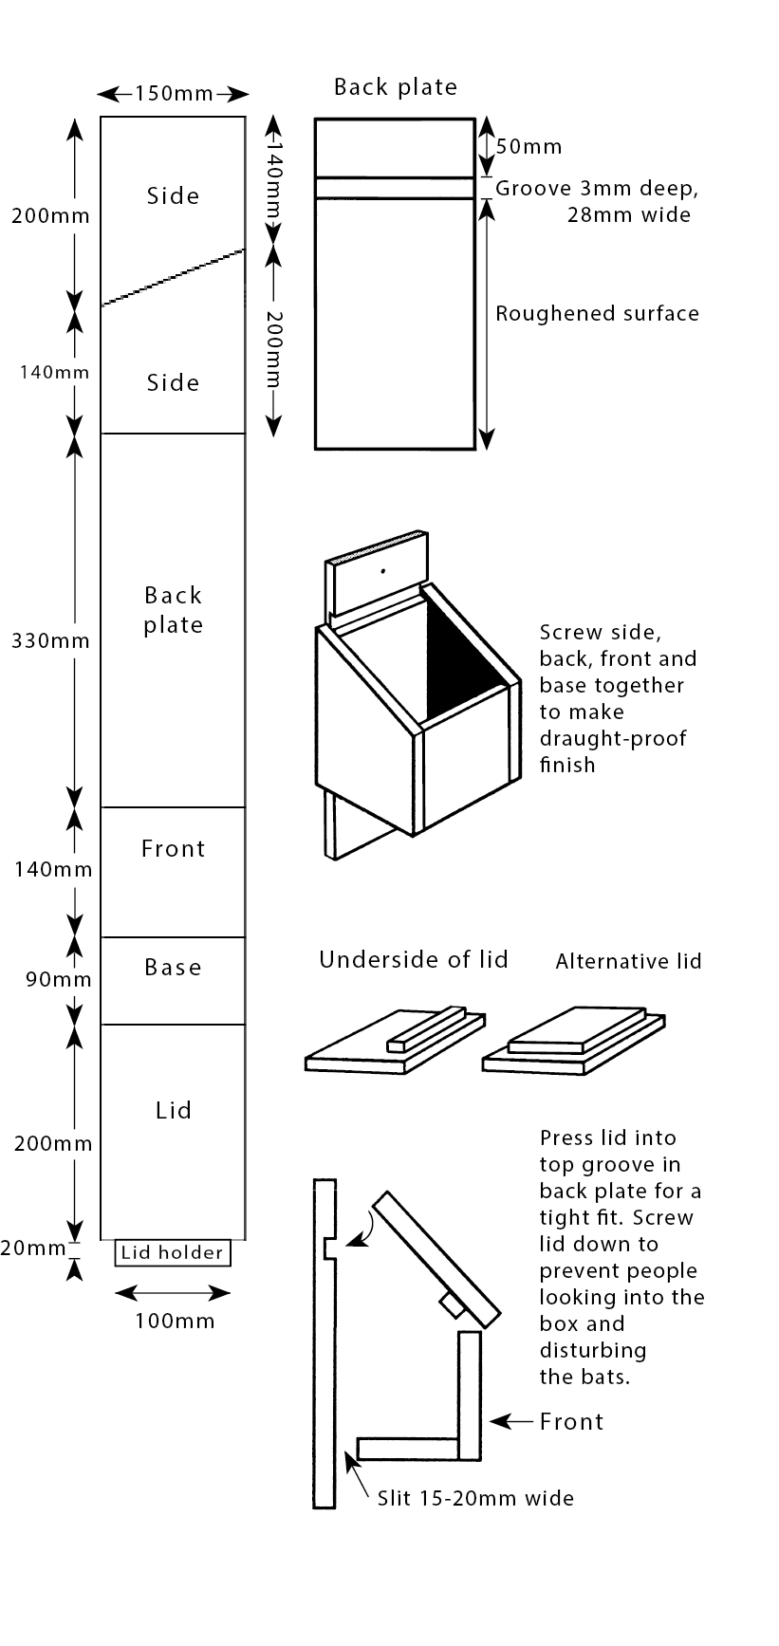
- Building your bat box. You'll need a sheet of timber 15cm wide by at least 1.1m long, as thick as possible to keep the bats insulated from too much cold and heat inside (ideally 1.5cm or more).
Note: the dimensions shown are for 20mm thick wood. If your wood is different to that, the dimensions of the Base should be 150mm by 130mm minus 2 x thickness of the wood, eg if the wood is 18mm thick, the base should be 150mm x 94mm.
Mark the wood with a pencil, according to the diagram, and then cut it in to the sections.
Nail all the pieces together as shown in the diagram, making the joints as airtight as possible.
- Choose your location. You could put it under the eaves of your house or, if you have a large garden, on the trunk of a mature tree. Ideally, look for a spot that is at least 3m (10 feet) from the ground, sheltered from strong winds and exposed to the sun for part of the day. Position your box so it faces between south-west and south-east. Make sure there is a clear flight line in.

